



The Heart Institute ACHD Program at Cincinnati Children's Hospital Medical Center in association with the International Society for Adult Congenital Heart Disease is pleased to announce the launch of the Learning Center site, a comprehensive resource for all ACHD interested professionals.

Available online for free at www.achdlearningcenter.org, the Adult Congenital Heart Disease Learning Center provides ACHD specific learning for all ACHD professionals and cardiology trainees.

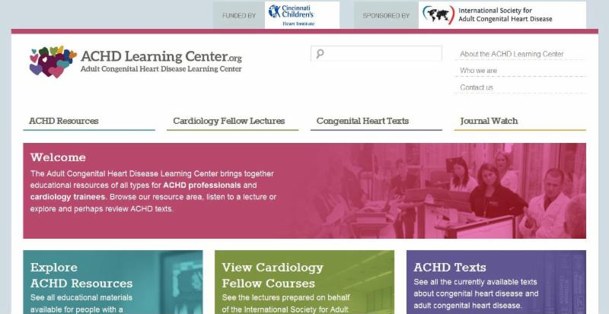

Resources include:
- Featured ACHD resources - web links covering 18 ACHD-related areas such as conference presentations, illustrations and websites. Try the Heart Disease and Pregnancy site.
- 15-Minute Basic ACHD lectures - 21 educational lectures posted; 34 more are being developed. Try "Repaired coarctation of the aorta".
- Congenital heart textbooks - 65 textbooks subdivided into twelve categories. See this recent text and a review.
- Congenital Heart Journal Watch - abstracts and full publications subdivided into six categories. Check out a featured ACHD article.

"The Learning Center site was developed by the International Society for Adult Congenital Heart Disease and the Heart Institute at Cincinnati Children's in the hopes that by spreading this high-quality educational material, the care of ACHD patients will be improved," says Dr. Gary Webb, Director of the Adolescent and Adult Congenital Heart Disease Program at Cincinnati Children's.

Please visit www.achdlearningcenter.org to find these high-quality educational resources. Let's improve the care of ACHD patients across the globe!

Sincerely,

The ACHD Learning Center Editorial Board

Dr. Gary Webb (chair) - Cincinnati Ohio USA.
Dr. Teiji Akagi - Okayama Japan.
Dr. Naser Ammash - Rochester Minnesota USA.
Dr. Helmut Baumgartner - Muenster Germany.
David Drapuch - Philadelphia Pennsylvania USA.
Dr. Jonathan Windram - Edmonton Canada.
Dr. Kate English - Leeds UK.
Dr. Richard Krasuski - Cleveland Ohio USA.
Philip Moons - Leuven Belgium.
Dr. Erwin Oechslin - Toronto Canada.
Dr. Els Pieper - Groningen, the Netherlands.
Dr. Simran Singh - New York City USA.

