Atrial Septal Defects
Atrial Septal Defects (ASD) occur in different locations within the atrial septum. The first feature you are likely to notice is dilatation of the right heart. This should prompt a thorough search for an ASD.
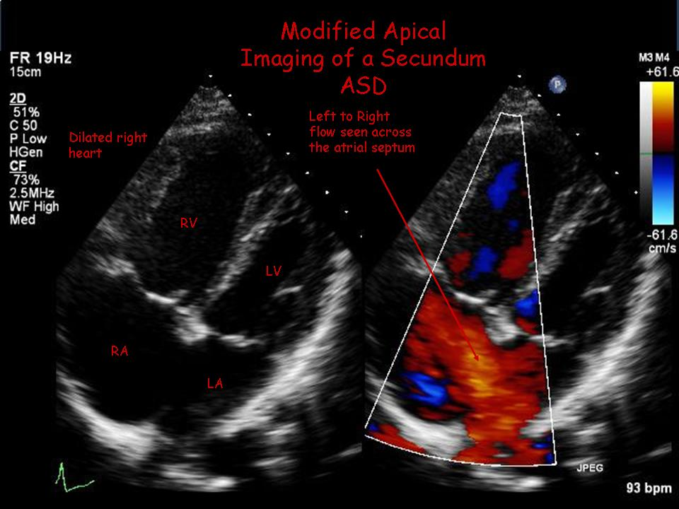

Primum defects are part of the AVSD spectrum and should be assessed accordingly.
Secundum defects are the most common type (approximately 75%), located in the mid septum in the region of the fossa ovalis.
Sinus Venosus defects are located postero-superior (or rarely postero-inferior) to the fossa ovalis and are commonly associated with partial anomalous pulmonary venous drainage, most frequently of the right upper pulmonary vein.
Rarely, there may be an atrial communication via an unroofed coronary sinus which mimics the haemodynamics of an ASD. ASDs may occur in isolation or may be fenestrated (multiple defects).
Secundum defects are the only defects amenable to percutaneous closure, and then only if there are sufficient margins.
2D Echo / Colour Doppler
Location and size of defect
Evidence of margins for percutaneous closure
Direction of shunt using colour (i.e. left to right/right to left/bidirectional)
Right heart size and function
Assess pulmonary venous position and drainage
Presence/severity of tricuspid regurgitation

Doppler Measurements
Tricuspid regurgitation peak velocity to assess RV systolic pressure and thus presence/absence of pulmonary hypertension

Common Pitfalls/Limitations
It may be difficult to see the defect itself (particularly sinus venosus defects) on 2D but if the right heart is dilated without any other known cause, an ASD may be present and further imaging investigations may be indicated (e.g. TOE).



